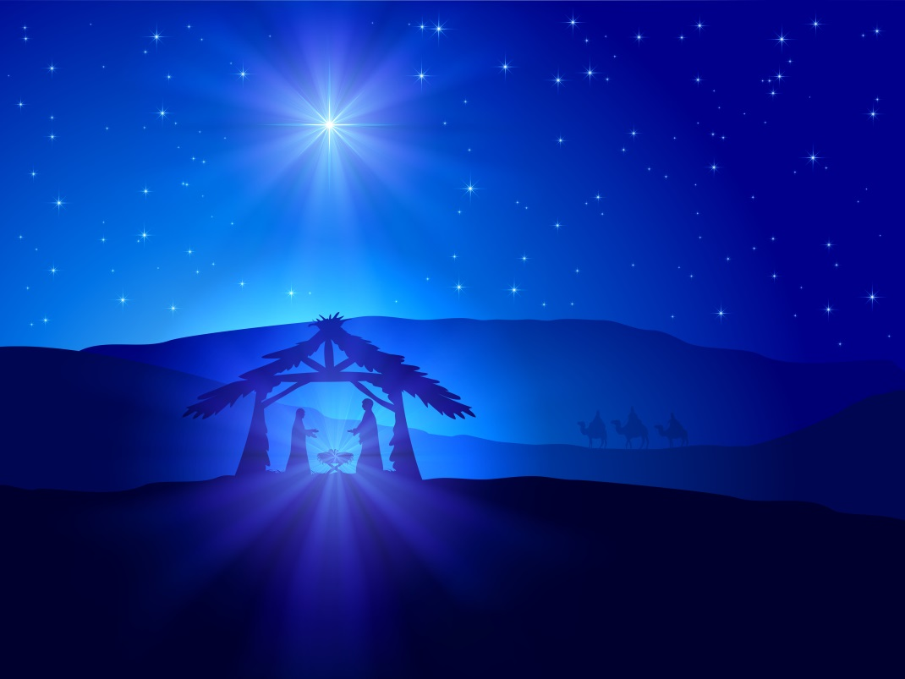
Christmas Season Holy Mass Schedule

4th Sunday of Advent: Dec. 23rd/24th
Sat. at 5 pm, Sun. at 8 am & 10:30 am

Christmas Eve: Dec. 24th
5 pm and 7:30 pm

Christmas Day: Dec. 25th
12:00 am midnight, 8 am and 10:30 am

Followed by our Christmas Dinner at 12 noon,
For those who will be alone or
cannot prepare one of their own

Feast of the Holy Family: Dec. 30th/31st
Sat. at 5 pm, Sun. at 8 am & 10:30 am

New Year’s Eve: Dec. 31st
Solemnity of Mary the Mother of God at 5 pm

Holy Hour to Ring in the New Year at 11 pm

New Year’s Day: Jan. 1st
8 am and 10:30 am

Epiphany: Jan. 6th/7th - Regular Sunday schedule

