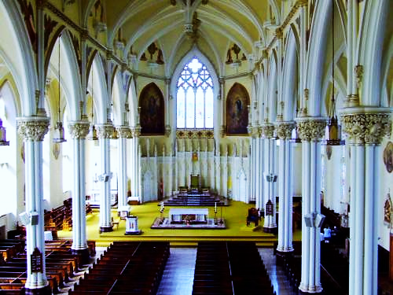

St. Mary’s Cathedral ITALIAN dinner
Fund raiser
For the sanctuary floor project
November 9th, 2019 6:00 pm
Parish centre-260 Brock St.
Tickets $ 50 in advance
-Menu-
Homemade Ravioli
Salad
Chicken alla Francesca, potatoes, vegetables
Dessert/coffee/tea
Complimentary glass of wine
Tickets will be on sale starting Sept. 21st after the Weekend Masses; Santina Donini, Pina Capelli, Wilma Saccon
Domenica 613-546-4934
Or the Office; 613-546-5521 ext. 3

