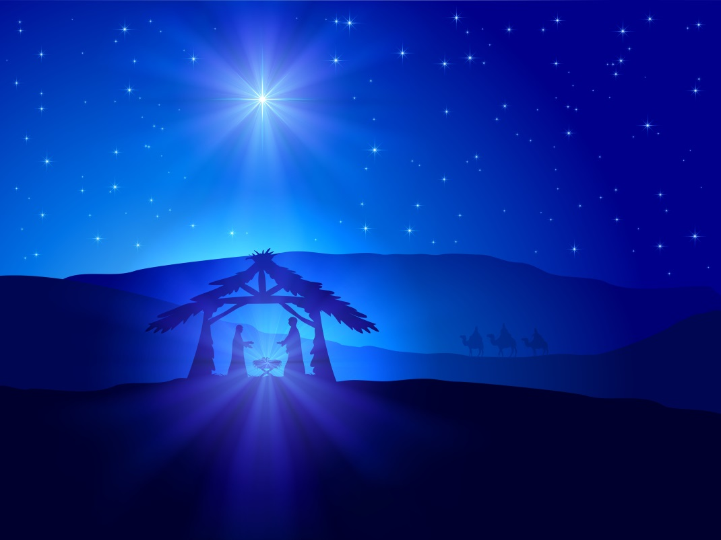
Christmas Season Holy Mass Schedule
Confessions before all Masses that take place in the cathedral

4th Sunday of Advent: Dec. 21st/22nd
Sat. at 5 pm, Sun. at 8 am, 10:30 am & 7:30 pm

Christmas Eve: Monday, Dec. 24th; 5 pm (Childrens’ Pageant) and 7:30 pm. Please bring an item for the food bank.

Christmas Day: Dec. 25th; 12:00 am midnight and 10:00 am

Followed by our Christmas Dinner at 12 noon, for those who will be alone or cannot prepare one of their own.

Feast of the Holy Family: Dec. 28th/29th
Sat. at 5 pm, Sun. at 8 am, 10:30 am & 7:30 pm

New Year’s Eve: Monday, Dec. 31st
Solemnity of Mary the Mother of God at 5 pm

Holy Hour to celebrate the New Year at 11 pm and
pray for the needs of the parish

New Year’s Day: Jan. 1st; 10 am

Epiphany: Jan. 4th/5th: Regular Sunday Mass Schedule

