Pastoral Letter #8 April 3rd, 2020

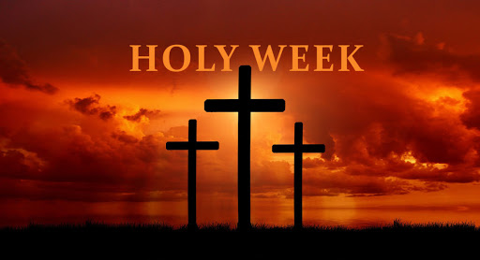
At the beginning of the Jewish Passover Meal, the youngest person present asks in song: “Why is tonight different from all other nights?” How apt for us this year. We are entering upon a Holy Week like no other. But when you think of it. That first Good Friday, the disciples were scattered and isolated, Jesus was alone on His Cross. The hopes, expectations and desires of the disciples seemed to be crushed with the one they thought was the Messiah hanging on a cross. Their world seemed to have collapsed. We are there. We enter this Holy Week with CoVid-19 not even able to gather to celebrate the most holy events of our Faith. Yet, it is Holy Week. I would encourage you to enter into it from your isolation. This truly is a Holy Week different from all other HolyWeeks, but, it can be a Holy Week that draws you more deeply into the mystery of the Cross more than any other Holy Week, as our whole world is groaning under the weight of the Cross of CoVid-19. I will be sending some suggestions over the next couple of days to assist you to enter more deeply in to the Mystery of the Cross and Resurrection.

For the Triduum we will be live streaming the liturgies from our cathedral. Please join us. Go to stmaryscathedral.ca on Holy Thursday at 7 pm, on Good Friday at 3 pm, on Holy Saturday at 8 pm for the Easter Vigil, and on Easter Sunday at 10:30 am. There you will be able to participate in the prayers and music as Archbishop Mulhall celebrates each of these Liturgies.

When I was the chaplain at Newman House, Queen’s University (2000 – 2004 AD) there was a student from Singapore in the MBA program. At the time he thought he might have a vocation to the priesthood, thus, we got to know each other very well. We have kept in touch ever since. He is now married with a lovely two year-old daughter, Faustina. He sent me this very beautiful version of the Stations of the Cross that is prayed in the cathedral in Singapore. It is in English. I would encourage you to pray the Stations of the Cross, this version or any other, each day of this week as we move through Holy Week. https://www.youtube.com/watch?v=a4-t2yFoXGM&t=703s

Also, for those of you with children, I am attaching a wonderful “Having a Successful Holy Week Kit”, that Christina Holt forwarded to me. It is very well done and worth a look for even those children have long grown.

Don’t forget to watch some of the video talks at the Virtual Catholic Conference that I sent out previously. They are free from noon today until this Sunday (April 5) evening. https://www.virtualcatholicconference.com/Home?r_done=1

The Archdiocese has put together a truly fabulous collection of resources for you to journey through Holy Week. Go to www.romancatholic.kingston.on.ca

Finally the National Catholic Lenten Mission will be preached by Bishop Bergie of St. Catharines and air on Vision TV (channel 28) on Monday and Tuesday (April 6 & 7) at 8 pm and repeated at 11 pm.

Please forward this email to anyone in the parish (or outside of it) that is not receiving it and encourage them to send me their email to sign them up on our email list.

I have been talking with some who are having a difficult time with the isolation. Please reach out to those you know are all alone and/or who don’t have family in the city. Those who are having a difficult time reach out yourselves as well; to parishioners or to me, 613-546-5521 ext. 4.

A Blessed Holy Week to you all!!

Missing all of you!!

Stay safe. Be prudent. Wash hands often. Practice social distancing. Above all, pray!

United in prayer in Christ
Father Shawn

