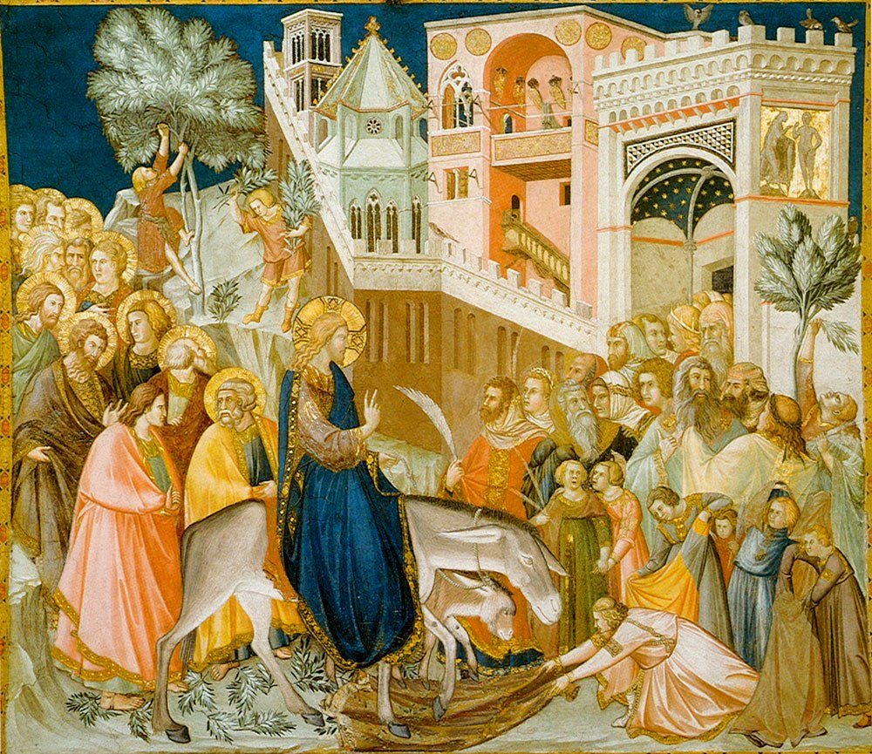

Hello my dear sisters and brothers in Christ

We begin Holy Week tomorrow with Palm Sunday. Make sure this week is a week different from all other weeks. Set aside a little more time to pray. The week builds to the celebration of the central mystery of our Faith, the Resurrection. Our Lord’s Passion and death should be a frequent theme in our prayer this week. I would encourage you to meditate on Matthew’s version of the Passion of Our Lord. Matthew 26:14 – 27:66 in your bibles or I have attached a file of it for you. Read it slowly and meditate on it. Let the reality of its gruesomeness and the depth of our God’s love for us in suffering this for us sink in. Hold a crucifix in your hand as you read. Stop and gaze upon it often. Before you read the gospel read the meditation on the Our Lord’s Passion that I have attached.

Among all the previous suggestions I have sent Formed.org has a vast array of suggestions to deepen your Holy Week. Go to https://watch.formed.org/holy-week-triduum.

The Palms will not be Blessed tomorrow as per the Archbishop’s instructions. They will be blessed and distributed at the time that we can all gather again.

I will be praying that this Holy Week be truly blessed for each of you.

Stay safe. Be prudent. Wash hands often. Practice social distancing. Above all, pray!

United in prayer in Christ
Father Shawn

