**The Cathedral of the Immaculate Conception of the**

**Blessed Virgin Mary, Mother of God**

The Mother Church of the Faithful of the Archdiocese of Kingston

The Most Reverend Michael Mulhall, Archbishop of Kingston

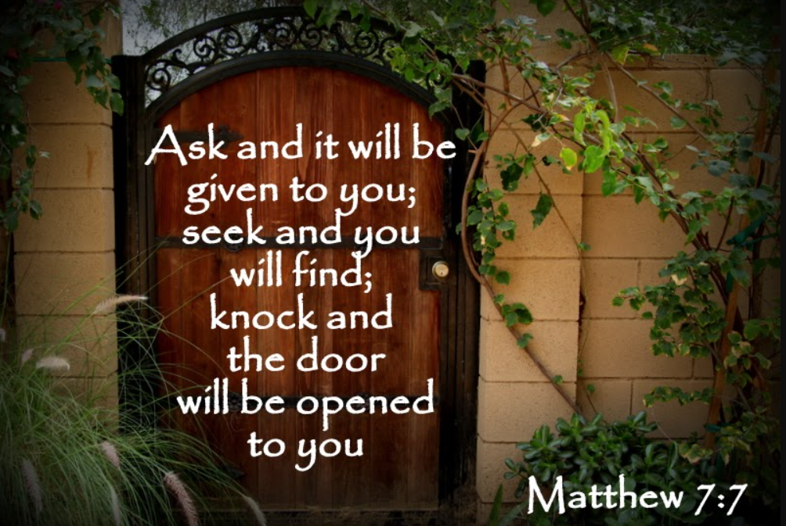**279 Johnson Street Kingston, Ontario 613-546-5521** [**www.stmaryscathedral.ca**](http://www.stmaryscathedral.ca)



**Mass Schedule**

**St. James Chapel:** Monday to Friday at 7:45 am

**St. James Chapel:** Monday to Friday at 12:10 pm

**St. Mary’s Cathedral: Sunday Vigil**: **Saturday** at 5pm **Sunday:** 8am, 10:30am, 7:30pm

**The Light is On! Opportunities for Confession**

**Weekday Confessions: Monday to Friday** 11:30 am to 12 pm

**Saturday Confessions:** 4:00-4:50

**Sunday Confessions:** 7:30 am to 7:55 am, 9:50 to 10:20 am & 7:00 to 7:25 pm

**Adoration and Confession: Wednesday** 6-9pm in the Cathedral

**Adoration of the Blessed Sacrament in St. James Chapel**

**Monday- Friday** 8:15am-9pm **Saturday :** 9am-4pm

**Clergy & Staff Contacts**

**Rector:** Father Shawn J. Hughes, [**rector@stmaryscathedral.ca**](mailto:rector@stmaryscathedral.ca)

**Deacon**: Deacon Blaine Barclay [**deacon@stmaryscathedral.ca**](mailto:deacon@stmaryscathedral.ca)

**In Residence:** Father Paul Finn, Father Timothy, Father Félix Roberge & Father Johney Kunnath

**Office Manager:** Liz Ford (On Maternity Leave), [**officemanager@stmaryscathedral.ca**](mailto:officemanager@stmaryscathedral.ca)

**Interim Office Manager:** Angela Gambin [**officemanager@stmaryscathedral.ca**](mailto:officemanager@stmaryscathedral.ca)

**Co-Ordinator of Evangelization:** Ann Lyng, [**ann@stmaryscathedral.ca**](mailto:ann@stmaryscathedral.ca)

**Drop-In Centre Manager:** Paty Velazquez, [**paty@stmaryscathedral.ca**](mailto:paty@stmaryscathedral.ca)

**5 pm Sat. Mass Music Director:** Brent Nuevo[**brent@stmaryscathedral.ca**](mailto:brent@stmaryscathedral.ca)

**10:30 am Sun. Mass Music Director:** Brent Nuevo[**brent@stmaryscathedral.ca**](mailto:brent@stmaryscathedral.ca)

**7:30 pm Sun. Mass Music Director:**Liam Noronha [**liam@stmaryscathedral.ca**](mailto:liam@stmaryscathedral.ca)

**Sacristan and Custodian:** Domenic Sanfilippo, [**domenic@stmaryscathedral.ca**](mailto:domenic@stmaryscathedral.ca)

**Custodian :** Rick Menard [**officemanager@stmaryscathedral.ca**](mailto:officemanager@stmaryscathedral.ca)

**Rectory Chef:** Anjelina Howell [**officemanager@stmaryscathedral.ca**](mailto:officemanager@stmaryscathedral.ca)

**Veronica’s Veil Shelter Co-Ordinator:** Ann Lyng, [**veronicasveil@stmaryscathedral.ca**](mailto:veronicasveil@stmaryscathedral.ca)

**Coat Drive Co-Ordinator:** Mike Chase,[**coatdrive@stmaryscathedral.ca**](mailto:coatdrive@stmaryscathedral.ca)

**Queen’s Newman House Catholic Chaplaincy:**

**Chaplain: Father Jan Kusyk** [**frjankusyk@gmail.com**](mailto:frjankusyk@gmail.com)

**Sign Up for the Daily Flocknote at** [**stmaryscathedral.ca/flocknote/**](https://stmaryscathedral.ca/flocknote/)

**St Mary’s Youtube Channel: www.youtube.com/@StMarysCathedral**

**Mass Intentions**

**Monday July 28th 7:45AM**✝June and Nick Sears **12:10 PM** ✝Isabella Roberts

**Tuesday July 29th 7:45AM** Living and deceased members **12:10PM** Intentions of Evelyn Thompson

Of the Overvelde family

**Wednesday July 30th 7:45AM** ✝Father Dan Ryan **12:10PM** ✝Deceased Family Members of

the Barrett, Cosgrove, Bossy, Dixon, and Myers Families

**Thursday July 31st 7:45AM** Intentions of Carmel Johnson Morrison **12:10PM** ✝Brian Cosgrove

**Friday August 1st 7:45AM** Intentions of Radoslaw Miksa and family **12:10PM** Intentions of Jack Thompson

**Saturday August 2nd 5:00 PM** ✝Francesco Cimellaro

**Sunday August 3rd 8:00 AM** ✝Betty Roy **10:30 AM** *Pro Populo*

**7:30 PM**✝Repose of the souls of the Bishops, Priests, and Deacons who were born a and/or served the Archdiocese of Kingston

|  |  |  |  |
| --- | --- | --- | --- |
| **MINISTRIES:** |  | **First Reading:** | **Second Reading:** |
| **Saturday August 2nd** | **5:00 PM** | Isabel Chase | Lynn Pritchard |
| **Sunday August 3rd** | **8:00 AM** | Dan Kasaboski | Ann Lyng |
| **Sunday August 3rd** | **10:30 AM** | Mark Levac | Teresa Marrello |
| **Sunday, August 3rd** | **7:30 PM** | Michelle Savoie | Lionel Ryan |

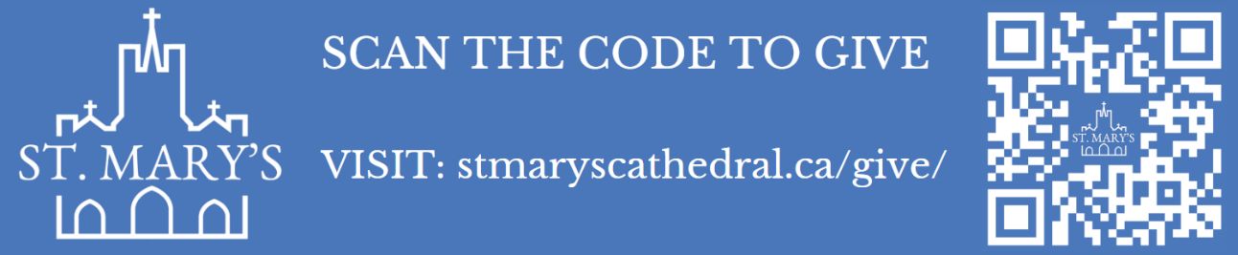

**Summer office hours: For July & August there will be no one in the office on Friday afternoons. Monday to Thursday 8:30 am to 3:30 pm.**

**Jubilee Year of Hope Pilgrimage to Fatima, Lourdes, Rome and Assisi**

**A few spots remaining! All pilgrims will receive the Jubilee Indulgence. If you are considering this please let Father Shawn or Father Justin know.**

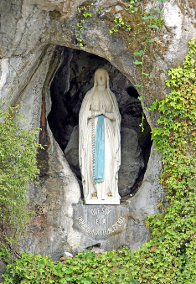**November 5–17, 2025**

Please join Father Justin Pulikunnel and Father Shawn Hughes who will travel November 5 to November 17 to Europe to receive the great graces of pilgrimage in this Jubilee Year.  The Pilgrimage will travel to Fatima, Lourdes, Assisi and Rome. In Rome we will visit Saint Peter's Basilica, the Sistine Chapel, and more. Entrust yourself to the Blessed Virgin Mary in Lourdes and Fatima ... be a Pilgrim of Hope in 2025! And we will visit the tomb of St. Francis of Assisi and Blessed Carlo Acutis (who will become St. Carlo Acutis on September 6th) For further information please do not hesitate to contact Ann Lyng: [ann@stmaryscathedral.ca](mailto:ann@stmaryscathedral.ca)

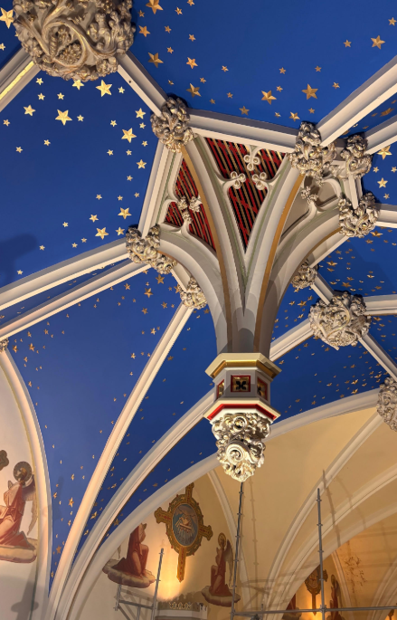**Restoration Updates**

As you can see, we are now going to covering the entire Cathedral ceiling with stars, so there are abundant stars available for sponsorship. Stars may be sponsored for $50 each and Angels for $1500. Donations are a tremendous blessing and will aid significantly to the success of this work. You can make your offering in memory of a deceased loved one, or mark significant occasions or anniversaries in yours or another’s life.

The stars will be numbered, and you will be provided with a map and the locations of your star(s).

If you would like to sponsor the restoration, please feel free to speak to Angela at 613 546 5521 x.3 or officemanager@stmaryscathedral.ca.

I am counting on your prayers for our renovation efforts through the intercession of Our Blessed Mother of the Immaculate Conception.



**THE COUNCIL OF NICAEA WAS HELD FROM MAY TO JULY OF THE YEAR 325. We are celebrating the 1700th anniversary of the Council and the writing of the Nicene Creed we use at Holy Mass.**

37. The mystery of humanity in its great dignity is also illumined by the eschatological dimension of the

Nicene symbol. Faith in the ‘resurrection of the dead’, also called the ‘resurrection of the

flesh’, [51]  affirms the beauty of the body and the beauty of what is lived in the world through the body,

despite human fragility and limitations. It affirms the value of this concrete personal body, which will be

raised up and transfigured, but will remain numerically identical. [52]  It thus makes an ethical demand: if

the genuine acts of love performed in and by the body in this life are in some way the first steps of the

risen life, respect for the body implies living everything that touches it uprightly and with purity. It

should be noted that Christologies that do not posit the full humanity of Christ run the risk of importing

a conception of salvation as an escape from the body and the world, rather than as our full

humanisation. Yet this anchoring in the world and the body, created good and fulfilled by the new

creation, is one of the hallmarks of Christianity. Here we find the deep link between creation and

salvation: all the human traits of Jesus received from Mary, his mother, are good news, and they invite

every human being to consider what makes his or her own humanity concrete as good news.

38. Moreover, the hope of the resurrection, like that of ‘eternal life in the world to come’, attests to the

immense value of the individual person, who is called not to disappear into nothingness or into the

whole, but to an eternal relationship with the God who chose each person before the foundation of the

world (cf. Eph 1:4). The election of Abraham, Isaac, and Jacob and the irrevocable covenant with the

people of Israel already reveal the covenant that God wishes to make with all nations and every human

being in indestructible fidelity. In the same way, the incarnation of the eternal Son in a single human

being confirms, establishes and fulfils the inalienable dignity of the person as a brother or sister of Jesus

Christ.

39. Our world today has an immense need to rediscover those aspects of the mystery of man that

present him in his greatness, without ignoring his misery: ‘The human being infinitely surpasses the

human being,’ said Blaise Pascal. [53]  This Christian conviction challenges all forms of anthropological

reductionism. Faith in the paternity, filiation and fruitful (‘pneumatic’) inspiration of human beings

underpins and guides every authentic conception of human autonomy, freedom and creativity. These

are rooted in God, Father, Son and Holy Spirit, for whom omnipotence, wisdom and love are one in the

gift of self. Conversely, the loss of faith in the resurrection and eternal life will lead to a refusal to give

the body its rightful place and to the sacred value of each individual in his or her uniqueness and

transcendence. Yet the Creator has revealed his intentions to us: ‘You wanted them to be a little less

than gods, crowning them with glory and honour.’ (Ps 8:6)

3.3 The beauty of the gift of the Church and of baptism

40. The various threads woven so far are tied together in the ecclesiological and sacramental

affirmations of the Creed. The faith of Nicaea also means believing in the Church ‘one, holy, catholic and

apostolic’ and in baptism ‘for the forgiveness of sins’. The Church and baptism are to be celebrated as

gifts that are also semper majora. Because they confirm and manifest the superabundant fullness of all

that is set out in the rest of the Symbol, they are the paradoxical objects of faith: it is a question of

recognising in them much more than can be seen. The Church is one beyond her visible

divisions, holy beyond the sins of her members and the errors committed through her institutional

structures, catholic and apostolic beyond divisions of identity or culture and the doctrinal and ethical

turmoil that constantly agitates her. In this sense, both ecclesiological ‘monophysitism’ and ‘Arianism’

must be avoided: the former underestimates, or even obscures, the human dimension of the Church,

while the latter overlooks the divine dimension of the Church in favour of a purely sociological and

functional vision. Similarly, in the faith, baptism is understood as the source of new life and purification

from sin beyond what is visible in the imperfect lives of the baptised themselves which are sometimes

distant from God. It unfolds and elevates the inviolable dignity of every human being by conforming

them to Christ, priest, prophet and king.

41. To ‘believe’ in the Church and to ‘confess’ a single baptism is to receive a gift of faith which makes it

possible for believers to discern at the very heart of their human and fragile dimension the active and

sanctifying presence of the Holy Spirit. The Spirit makes the Church one, holy, catholic and apostolic, and

gives baptism its efficacy. To ‘believe’ in the Church and in baptism is also to perceive in and through the

Church the saving action of Christ. Just as Christ is the fundamental sacrament of God, his real and active

presence in the real symbol of his humanity, so the Church is the ‘universal sacrament of

salvation’. [54]  Finally, to ‘believe’ in the Church and in baptism is to discern in them the presence of the

Triune God. The Church is semper major, for she finds her source and her foundations in the Triune God,

and in her live the Father, the incarnate Son and the Spirit. In her, the faith of Nicaea is proclaimed and

celebrated – through baptism and the other sacraments: ‘Glory to you, Father and Son with the Holy

Spirit in the holy Church.’ [55]

42. At the crossroads between soteriology and anthropology, believing in the Church and confessing a

single baptism confirms and unfolds the immensity of salvation and the mystery of the human being.

Salvation is not simply an individual process, but a communal and supernatural one, received through

the cooperation of other people who are our neighbours, and producing spiritual fruit for others who

are also our neighbours. [56]  This sheds light on the nature of the human being, who is not an isolated

monad but a social being, inserted into a family, a nation, a community of faith, and into the whole of

humanity. [57]  Consequently, faith in the Church and in baptism implies that redemption is worked out

in visible acts and structures, linked to the corporeal dimension of the individual and the social body,

which unfold in history. These are the locus of the life-giving and inspiring Spirit, who works between

and beyond their limits to reach every human being. At bottom, by bearing witness to the link between

the individual and the whole, between corporeality and inscription in history, the Church is part of the

work of Christ who ‘fully reveals human beings to themselves.’ [58]  In a particular way, as the ‘sacrament

of unity’, [59]  the Church professed by the faith of Nicaea is the sign and instrument of the unity of all

these aspects of the human person and of humanity as a whole: the Christian vision of humanity

explodes the narrowness of all reductionisms that reject either the community in favour of the

individual or the individual in favour of the collective, and that do not tend towards unity.

4. Celebrating the immensity of salvation together: the ecumenical significance of the faith of Nicaea

and hope for a common date for the celebration of Easter

43. The faith of Nicaea, in all its beauty and grandeur, is the common faith of all Christians. All are united

in the profession of the Nicene-Constantinopolitan symbol, even if not everyone gives the Council and

its decisions the same status. The year 2025 is therefore an invaluable opportunity to emphasise that

what we have in common is much stronger, quantitatively and qualitatively, than what divides us:

together, we believe in the Triune God, in Christ as truly human and truly God, and in salvation through

Jesus Christ, according to the Scriptures read in the Church and under the guidance of the Holy Spirit.

Together, we believe in the Church, baptism, the resurrection of the dead, and eternal life. The Council

of Nicaea is particularly revered by the Eastern Churches, not simply as one Council among many or the

first in a series, but as the Council par excellence, which promulgated the confession of faith of the ‘318

Orthodox Fathers’.

44. Consequently, the year 2025 is an opportunity for all Christians together to celebrate this faith and

the Council that gave it expression. Theological ecumenism rightly focuses its attention and efforts on

the unresolved knots of our differences, but it is undoubtedly just as fruitful, if not more fruitful,

to celebrate together, in order to move towards the re-establishment of full communion between all

Christians, so that the world may believe. We have already emphasised how the insistence of the

different Christian traditions makes it possible to highlight the richness of the text of the Symbol

(cf. supra § 17). The common celebration of Nicaea could be an ecumenical journey of mutual

enrichment that will offer, along the way, a better understanding of the mystery, greater communion

between ecclesial traditions, and a stronger attachment to the common profession of the Christian faith.

45. One of the aims of Nicaea was to establish a common date for Easter to express the unity of the

Church throughout the Oikoumenē. Unfortunately, there is still no unanimous agreement on a common

date. The divergence of Christians over the most important feast in their calendar creates pastoral

damage within communities, even to the point of dividing families, and causes scandal among non-

Christians, thus affecting the witness given to the Gospel. This is why Pope Francis, the Ecumenical

Patriarch Bartholomew, and other Church leaders have repeatedly called for a common date for

celebrating Easter. It so happens that in 2025, Easter is celebrated on the same date in both East and

West. Would this not be a providential opportunity to continue celebrating the Passion and Resurrection

of Christ, the ‘feast of feasts’ (Byzantine Matins of Easter), in communion across all Christian

communities? There are a number of realistic enough proposals for an undivided date. On this question,

the Catholic Church remains open to dialogue and to an ecumenical solution. Already in the appendix to

the Constitution Sacrosanctum Concilium, the Second Vatican Council did not oppose the introduction of

a new calendar, but stressed that this should be done ‘with the consent of those to whom this question

is of importance, especially of the brethren separated from communion with the Apostolic See’. [60]

Note the importance attached by the Eastern world to the elements laid down in the aftermath of

Nicaea to determine the date of Easter: Easter is to be celebrated ‘on the first Sunday following the full

moon that follows or coincides with the vernal equinox’. [61]  Sunday evokes the resurrection of Christ on

the first day of the week, while the full moon following the spring equinox recalls the Jewish origin of

the festival, 14 Nissan, but also the cosmic dimension of the resurrection, since the spring equinox

evokes the moment when the length of day prevails over that of night and nature comes back to life

after the winter.

46. It should be noted that it was at the Council of Nicaea that the Church decisively chose to separate

itself from the date of the Jewish Passover. The argument that the Council wanted to distance itself

from Judaism has been put forward, based on the Emperor Constantine&#39;s letters as reported by

Eusebius, which include anti-Jewish justifications for the choice of an Easter date not linked to 14

Nissan. [62]  However, a distinction must be made between the motivations attributed to the Emperor

and those of the Council Fathers. In any case, nothing in the Council&#39;s canons expresses this refusal of

the Jewish way of doing things. We cannot ignore the importance for the Church of the unity of the

calendar and the choice of Sunday to express faith in the resurrection. Here today, as the Church

celebrates the 1,700 th  anniversary of Nicaea, are once again some aims for reflecting on the date of

Easter. Besides the question of the calendar, it would be desirable always to better underline the

relationship between Easter and Pesaḥ in theology, in homilies as well as in catechesis, in order to reach

a broader and deeper understanding of the meaning of Easter.

47. At Easter vigils and in every baptismal liturgy, the Nicene-Constantinopolitan symbol is proclaimed in

its most solemn form, which is dialogue. This profession of faith, which is the foundation of individual

Christian life and the life of the Church, will find its whole strength if it is rooted in the revelation made

to our ‘elder brothers’ and our ‘fathers in the faith’ [63]  and lived in visible communion by all Christ’s

disciples.

Chapter 2

The Symbol of Nicaea in the life of believers:

‘We believe as we baptize and we pray as we believe.’

Introduction: Living out the faith we confess

48. The faith professed at Nicaea has a rich dogmatic content that was decisive in establishing Christian

doctrine. However, the challenge of this doctrine was and is still to nourish and guide the life of the

believer. In this sense, it is possible to highlight a real spiritual treasure of the Council of Nicaea and its

Creed, a ‘source of living water’ from which the Church is called to draw today and always. It was to

protect access to this living water that Saint Anthony agreed to leave his hermitage to testify against the

Arians in Alexandria. [64]  This treasure is directly manifested in the way in which the Nicene faith was

born of the lex orandi and nourished by it. [65]  Moreover, the synods never intended to limit their

debates to the speculative domain of statements of faith. On the contrary, the participants in these

synods were keen to discuss the whole of ecclesial life, the best way to imbibe and practise the truths of

the faith on a daily basis and, conversely, to regulate their teaching on liturgical, sacramental and even

ethical orthopraxis. [66]  The bishops, in short, spiritually brought with them to the councils the members

of the body of the Church, with whom they shared the life of faith and prayer, and with whom they sang

the praise and glory of the Father, the Son, and the Holy Spirit, one God. To grasp the spiritual and

theological significance of the Nicene dogma, we need to explore how it was received in the liturgical

and sacramental practice, catechesis and preaching, prayer and hymns, of the fourth   century.

Baptism and Trinitarian faith

49. Even before the doctrine of the Trinity was developed theologically, faith in the Trinity was at the

foundation of the Christian life celebrated in baptism. The profession of baptismal faith pronounced in

the sacramental formula of baptism did not simply express a theoretical mystery but the living faith that

referred to the reality of salvation given by God, and therefore to God himself. Baptismal faith provides

a ‘knowledge’ of God that is at the same time an access to the living God. Thus, the apologist

Athenagoras asserts: ‘There are [...] human beings [...] who allow themselves to be guided solely by the

desire to know the true God and his Word, to know what is the unity of the Son with the Father, what is

the communion of the Father with the Son, what is the Spirit, what is the union and distinction of the

three persons thus united, the Spirit, the Son and the Father.’ [67]

50. This is why the baptismal formula, in which the Father, Son and Holy Spirit are placed on an equal

footing, constitutes the central argument against Arius and his followers, much more than recourse to

theological reasoning. This is as true of Ambrose [68]  and Hilary [69]  as it is of Basil of Caesarea, Gregory

of Nyssa and Ephrem the Syrian. [70]  Likewise, Athanasius insists that the Son is named in the baptismal

formula not because the Father is insufficient, nor simply by chance, but because:

He is the Word of God and God’s own Wisdom and, being his radiance (apaugasma), he is always with

the Father. For this reason, when the Father dispenses grace, he can give it only in his Son, for the Son is

in the Father as the radiance of light [...] He whom the Father baptizes, the Son also baptizes, and he

whom the Son baptizes is sanctified in the Holy Spirit. [71]